**Mini Project - Car Showroom Management – Back End**

**Name:** Badri MSV **Roll No:** 195002017

**Name:** Dinesh B **Roll No:** 195002031

**Class:** IT – A

**Subject:** UIT1312 - Database Management Systems and Applications Laboratory

**Back End: Oracle 11g Database**

**Queries and Outputs:**

create table cartype

(

typeid number,

typename varchar(30),

seatcapacity number,

fueleconomy varchar(30),

fueltype varchar(30)

);

create table brand

(

brandid number,

brandname varchar(30),

dealername varchar(30)

);

create table details

(

cno number primary key,

cname varchar(30),

brandid number,

typeid number,

priceUSD number,

noofunits number

);

insert into cartype values(101,'Sedan',4,'1.9 Gal/100 mi','Gas');

insert into cartype values(102,'Sedan',4,'25 kWh/100 mi','Electric');

insert into cartype values(103,'SUV',7,'7.1 Gal/100 mi','Gas');

insert into cartype values(104,'SUV',7,'35 kWh/100 mi','Electric');

insert into cartype values(105,'Hatchback',5,'3.2 Gal/100 mi','Gas');

insert into cartype values(106,'Hatchback',5,'31 kWh/100 mi','Electric');

insert into cartype values(107,'Sports',3,'3.8 Gal/100 mi','Gas');

insert into cartype values(108,'Sports',3,'48 kWh/100 mi','Electric');

insert into brand values(201,'Toyota','Lanson and Brothers');

insert into brand values(202,'Tesla','Tesla Motors');

insert into brand values(203,'Suzuki','Maruthi Co');

insert into brand values(204,'Hyundai','Daikun Motors');

insert into brand values(205,'Renault','India Motorcorp');

insert into brand values(206,'Ford','Chennai Ford');

insert into details values(1,'Tesla Model S Roadster',202,108,250000,4);

insert into details values(2,'Mustang GT',206,107,300000,7);

insert into details values(3,'Fortuner',201,103,200000,10);

select * from cartype;

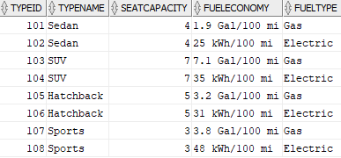

select * from brand;

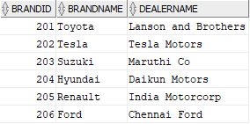

select * from details order by cno;

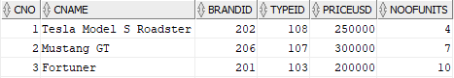

select cname, brandname,priceUSD, noofunits, typename, fueltype, fueleconomy, seatcapacity, dealername from details d, cartype t,brand b where d.typeid = t.typeid and d.brandid = b.brandid;

